Dr. S.KEDHARNATH MEMORIAL LECTURE 2013 (KML-2013)

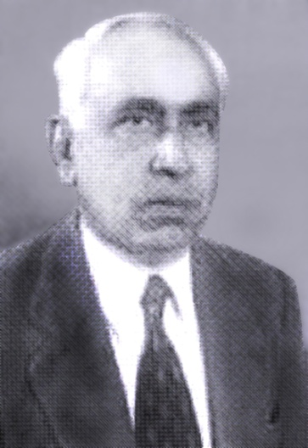
1921 – 2004

In honour of the pioneering contribution and services of Dr.S.Kedharnath in the field of Tree Improvement, an Annual Memorial Lecture in his name will be conducted at IFGTB, Coimbatore from this year onwards. Dr.S.Kedharnath pioneered in implementing scientific and systematic Genetic Improvement programs in species such as Teak, Sandal, Pine and Eucalypts in our country and is often referred to as the ‘Father of Forest Genetics in India ’. He served as the Forest Geneticist and Director Biological Research in the Forest Research Institute, Dehradun. He specialized in applied tree improvement, cytogenetics, mutation breeding and hybridization. The first Dr.S.Kedharnath Memorial Lecture (KML-2013) is scheduled at IFGTB, Coimbatore on the 4th April, 2013. Dr.S.Nagarajan, ICFRE Chair of Excellence in Forest Genetic Resources (Former Chairman of PPVRI, Ministry of Agriculture, Government of India) will be delivering the first lecture in these series. About 100 invitees of Forestry Academia, Forestry Professionals and Breeders of various tree and agricultural crops from different Institutions are expected to attend this lecture.

Director, IFGTB

